**DAILY ONLINE ACTIVITIES SUMMARY**

|  |  |  |  |  |  |  |  |  |
| --- | --- | --- | --- | --- | --- | --- | --- | --- |
| **Date:** | **8-06-2020** | | | | | **Name:** | **Kavya** | |
| **Sem & Sec** | **6th & A** | | | | | **USN:** | **4al17cs041** | |
| **Online Test Summary** | | | | | | | | |
| **Subject** | | **CNSC** | | | | | | |
| **Max. Marks** | | **60** | | **Score** | | | **28** | |
| **Certification Course Summary** | | | | | | | | |
| **Course** | A concise guide to getting started with machine learning. | | | | | | | |
| **Certificate Provider** | | | **Udemy** | | **Duration** | | | **3 hours** |
| **Coding Challenges** | | | | | | | | |
| **Problem Statement:1.** Python program to find whether a string is a palindrome or not  2. Java program to delete a node from the middle of the singly linked list  3. C Program to Generate All the Set Partitions of n Numbers Beginning from 1 and so on  4. Write C++ program to Check whether a number can be represented as difference of two squares | | | | | | | | |
| **Status: Yes, I have uploaded all the programs.** | | | | | | | | |
| **Uploaded the report in Github** | | | | | **Yes** | | | |
| **If yes Repository name** | | | | | [**https://github.com/kavya-077/DAILY-STATUS**](https://github.com/kavya-077/DAILY-STATUS) | | | |
| **Uploaded the report in slack** | | | | | **Yes** | | | |

Online Test Details: (Attach the snapshot and briefly write the report for the same)

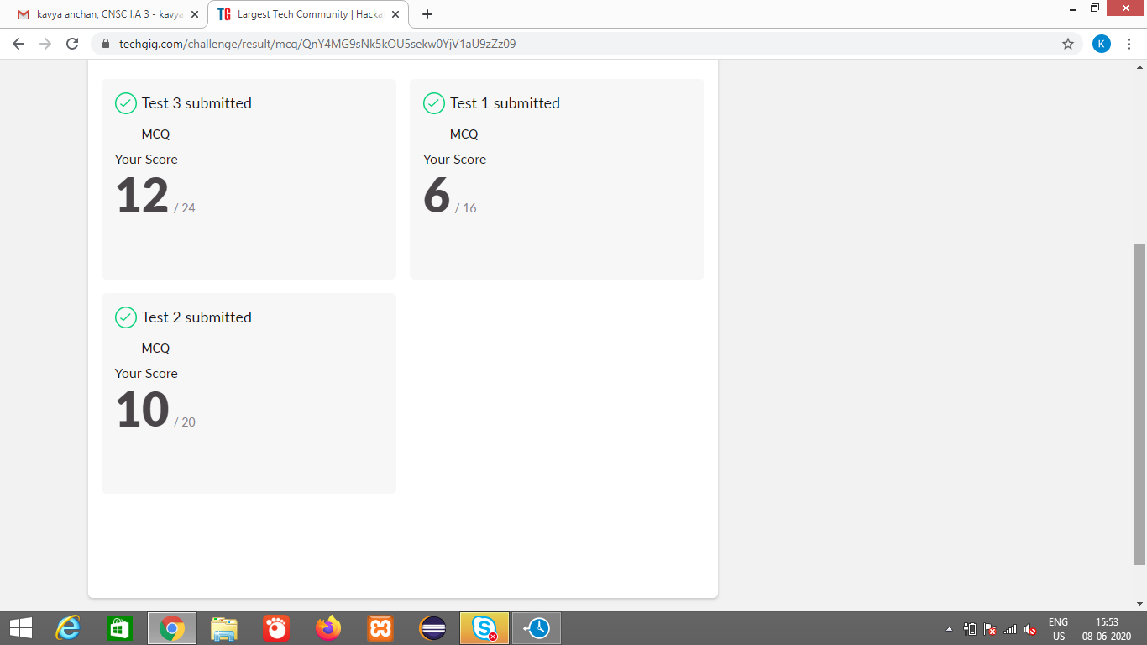

Certification Course Details: (Attach the snapshot and briefly write the report for the same)

**A concise guide to getting started with machine learning**.

**What we’ll learn**

* Machine learning
* Prediction Models
* Scikit learn
* Python
* Numpy
* Pandas
* Matplotlib

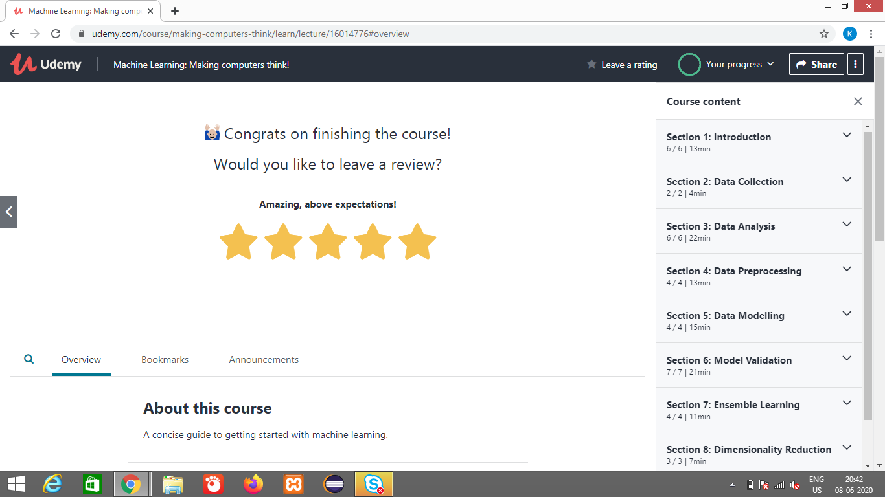

<https://github.com/alvas-education-foundation/kavya-onlinecourse>

Coding Challenges Details: (Attach the snapshot and briefly write the report for the same)

<https://github.com/kavya-077/DAILY-STATUS>

<https://github.com/alvas-education-foundation/kavya-OCA>